
BroadVision

One-To-One™

One-to-One Application Development:

Recommended Application Development
Practices and Environments

DRAFT Document

BroadVision (UK) Ltd.
Hare Hatch Grange
Bath Road
Hare Hatch
Berkshire
RG10 9SA
Tel: 01753 701067

Contents


1. Introduction 3
1.1 The One-To-One Development Architecture and Components 3
2. Configuring the One-To-One Development Environment 5
2.1 Recommended Development Configurations 6
2.1.1 Personal Development Environment 6
2.1.2 Central Testing Environment 7
2.1.3 Staging Environment 7
2.2 Personal Development Environment Configurations 8
2.2.1 Configuration 1 9
2.2.2 Configuration 2 11
2.2.3 Configuration 3 11
2.2.4 Separate Database Tablespaces 12
2.3 The Central Development/Testing Area 13
2.3.1 Revision Control 14
2.3.2 List of Artifacts 14
3.0 The Development Process 15
Build and Test 15
Quality Assurance 15
Code Walkthroughs 15
Unit/White Box Testing 16
Link Testing 16
Prototyping 16
Change Control 16
Appendix A - C++ Coding Standards 17
Naming 17
General Layout 17
File layout and Commenting( refer to the example) 18
Implementation Files 18
Hungarian Notation 20

1. Introduction
This document describes “Best Practices” guidelines that may be easily adopted to provide an efficient, stable and robust development environment for BroadVision projects. These guidelines form part of an overall implementation process, the objective of which is to ensure that an efficient development process is adopted, ultimately resulting in the production of a high quality product.

Potential pit falls are highlighted and solutions offered to help avoid such situations.

1.1 The One-To-One Development Architecture and Components

To understand the One-to-One development environment, we need to understand the key components in the One-to-One architecture:

Key issues of BroadVision’s n-layer architecture are:

- Each layer can be changed independently of one another allowing separation of roles.
- Each layer is data-driven so that the underlying data model change will not affect the code.
- Each layer is open for customisation, integration, and supports standards.
- Each layer is modular with well-defined functional application units.

Layer Element Role

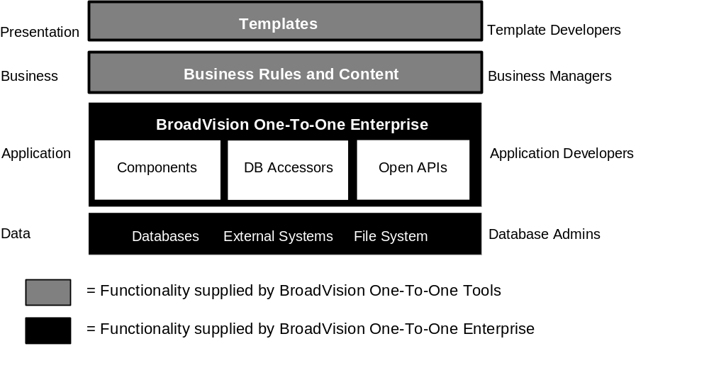
Figure 1: The N-layer architecture of BroadVision One-To-One Enterprise

Functionally, the BroadVision open architecture can be viewed as N-layer as shown in Figure 1. Each layer in this diagram represents a specific function with an individual’s functional role associated with the layer. For example, the role of a template/script developer is to develop the application logic and process control, whereas a business manager takes charge of defining what content should be shown to whom and when.

The functional layers are:

Presentation layer: represented by a series of templates/scripts, which are dynamically rendered for each user. Templates are comprised of dynamic elements written in server-side JavaScript with static elements written in HTML.

Business layer: represented by business rules and contents:

- Business managers control the business behaviour of the system by defining matching criteria and business rules. Matching rules control whom should see what content. Business rules control general business logic such as a sales person’s commission rate or the discount a preferred customer is entitled to receive.
- Content professionals make the contribution to the site, including publishing, distribution, setting workflow/approval processes, scheduling, etc.

Application layer: represented by a combination of elements:

- The BroadVision One-To-One Enterprise RMS provides fundamental system services such as control flow, validation and error reporting, and one-to-one functions, such as personalisation and content and profile management.
- Components (or “application objects”) provide a level of abstraction for accessing the basic application logic and database contents. Based on presentation logic defined in JavaScript, components manipulate the application logic and derive necessary contents accordingly. Together, JavaScript and components produce personalised pages with dynamic contents at runtime.
- Database accessors are gateways to various data sources. Database accessors are implemented as CORBA servers. BroadVision database accessors access the BroadVision databases, which store data created within BroadVision systems based on defined database models. Specific database accessors access each database. There are separate CORBA servers implemented for each accessor.
- Open APIs define a flexible way of communicating with BroadVision through C++ interfaces.

Data layer: includes databases and external data sources. With a flexible data model, BroadVision’s database accessors give the BroadVision system a logical look at the data by creating an extended data schema even though the data is separated physically.

2. Configuring the One-To-One Development Environment

Keeping the BroadVision architecture in mind, there are several ways to configure your development environment to leverage this open architecture model. First, identify the tasks to be performed:

- Installation of Hardware, OS, Web Server, RDBMS, and One-to-One Enterprise.
- Application Development of DB schema, JavaScript templates/scripts, components, CORBA servers and content tagging
- Application Configuration of the Publishing Center and the Command Center

Each application to be developed has one or more engineers that need to work together and orchestrate their efforts in such a way that provides an efficient and productive. You have common artifacts that must be shared and several groups that must share these resources.

To set-up a multiple developer environment for One-To-One on a single host, each installation needs a unique (see Figure 2):

- $BV1TO1_VAR directory of configuration specific files. See the sections “Files and directories,” and “One-To-One variables” in the Installation and Administration Guide for further information.
- $IT_DAEMON_PORT port number for accessing the (ORB). Ideally, each should also have a unique $IT_DAEMON_BASE to stop servers competing for the same sockets. See the section “One-To-One variables” in the Installation and Administration Guide for further information.
- Database to store installation specific information. Alternately, each installation must at least use a different database user account. See the section “Database variables” in the Installation and Administration Guide for further information.
- Script and Page template directories. See the section “Configuring the Interaction Manager” in the Installation and Administration Guide for further information.
- Component and dynamic object library directories to contain the components objects specific to the site. Each installation has a different shared object library. See the section “Configuring the Interaction Manager” in the Installation and Administration Guide for further information.
- Gateway server. Different versions of One-To-One require different CGI server instances. To run different versions of One-To-One on the same machine, give each CGI gateway a unique name. See the section “Working with a standard CGI gateway” in the Installation and Administration Guide for further information.

Additionally:
- Run one (named) Interaction Manager for each One-To-One installation.

- The multiple installation may share the same HTTP daemon as long as each application has a different starting page; the first page that the visitor sees. That page will then direct the visitor into the correct One-To-One application. Alternately, each installation can use its own HTTPd. To run multiple versions of One-To-One on one host, such as for separate development and production systems, install the One-To-One software for each into separate directories, and have each system access a separate database.

- When you install a new One-To-One system, the database and $BV1TO1_VAR directory are both empty. Both get configured and populated when you run the bvconf utility to start the system. This utility gets the site’s configuration information from the bv1to1.conf file located in the $BV1TO1_VAR/etc directory. If it doesn’t find the file in that directory, it reads the default configuration from the bv1to1.conf.default file in the $BV1TO1/lib directory.

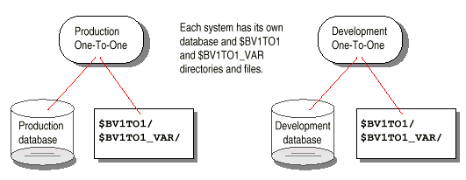
Figure 2: Separate Developer Environments

2.1 Recommended Development Configurations

A recommended development configurations should consist of Personal Development Environments for each developer, a Central Testing Environment, and a Staging Environment, as illustrated in Figure 3.

2.1.1 Personal Development Environment
Each developer should be provided with an isolated development area.

Unit testing should be performed on each artifact before being copied to the Central Testing Environment.

2.1.2 Central Testing Environment

This environment should reflect the latest stable version of the project. All scripts, component and configuration files must be functional and stable. Treat this area as the “master” copy of the project’s development; effectively a stable “snap shot” of the current development process.

Copies of all artifacts, scripts, components, etc, reflect the latest versions; and should be treated as “read-only” versions. It is imperative that if more than one developer is working on the same artifact that they are start developing from the same source. When completed development tasks are “booked” back into the Central Testing Environment.

The revision control tool must be able to address any differences between the worked upon artifact and the original; i.e. have a suitable merge/conflict management facility. Subsequent development on that artifact, ignoring those currently being worked upon, should start by sourcing that version of the artifact from this area.

2.1.3 Staging Environment
All system and integration testing should be performed on this machine, prior to moving the development to the production machine.

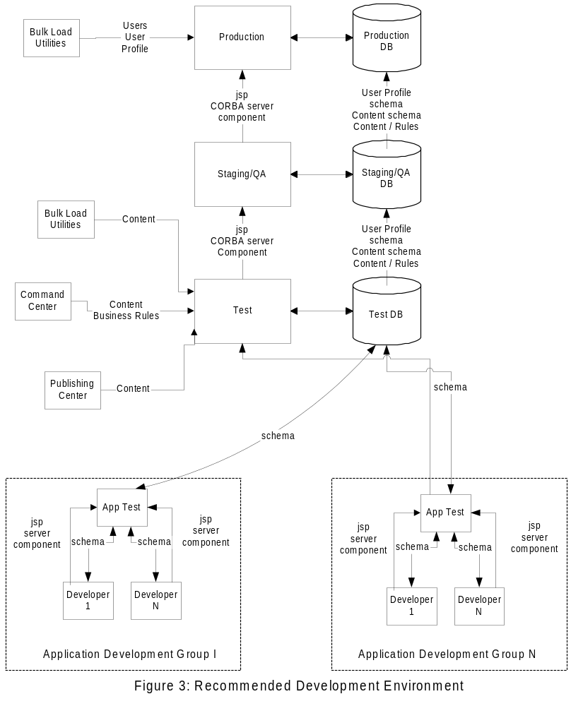

2.2 Personal Development Environment Configurations
Several Personal Development Environment configurations are possible, depending upon the nature of the development work being performed. Three examples follow to illustrate the flexibility that engineers can deploy in their environment. These allow engineers to work effectively and efficiently in developing One-to-One applications. These are logical representations of the configurations. Each configuration can be deployed all on one physical system (box) or distributed on several systems. On a single box, the processes can be run without conflict allowing for a low hardware and network overhead configuration. It is important to ensure that each developer has such an environment, otherwise significant problems to do with version control and system downtime can occur.

2.2.1 Configuration 1
This configuration is optimal for developers creating mainly JSP scripts and some new components. For this configuration, there is a single One-to-One instance, with several sets of Interaction Managers deployed, one per developer, as shown below:
Web Server
1
Interaction
Manager 1
CORBA
Servers
RDBMS
Interaction
Manager N
Web Server
N
Configuration 1
•
Single One-To-One Instance
•
Multiple sets of Interaction Managers (one per developer)
•
Corresponding set of web servers (one per developer)
•
Appropriate for developing JSP scripts and components only.
To create this environment, follow the below steps:

- Install BroadVision with a distinct $BV1TO1_VAR directory (see the Installation and Administrators Guide for further information).
- Create a separate UNIX account for each developer. Under each developer’s home directory, create the following directory structure:

htdocs | Web server document root.
cgi-bin | Web server cgi-bin directory.
scripts | Script directory.
script_library | Start-up script directory.
lib/components | Component library, including source files and libraries.

Creating such a directory structure for each developer will ensure that an isolated development environment is provided. Changes made to any of the static Web pages, scripts, start-up scripts or components will not impact upon the rest of the development team.

- Create a set of Interaction Managers, one per developer, using the command imgr_conf –a configure (see the Installation and Administrators Guide for further information). In order to allow each developer to easily know which Interaction Manager belongs to them, you can name the IM after the appropriate developer; see Table 1 below.
If creating a separate Web Server instance for each developer, as outlined in step 3, make sure that the appropriate HTTPD port settings are specified during the IM configuration process (or edit the appropriate IM .cfg file).
As outlined in Step 2, each developer, and hence IM, will have a separate set of script and Web server document root directories, start-up scripts directories, and component libraries (see Table 1).
Make sure that the IM configuration only includes the directory paths specified in Step 2. Do not allow any shared libraries to be included in the various paths; unless the artifacts referenced by this path are read only versions.
- Create a separate Web Server instance for each developer, assigning a different HTTPD port number. This configuration allows you to have NSAPI for everyone, although the cgi gateway is fine for development, as well as the ability to keep separate HTTP document roots.
- Configure the appropriately named gateway program for each developer, and place it under their cgi-bin directory.

Table 1 illustrates a typical development environment, recommended for Configuration 1. As you can see from Table 1, each developer is provided with a separate HTTP Port (which specifies a unique Web server document root and cgi-bin area), Interaction Manager, gateway program, script root, start-up script root and component library.

Developer | HTTP Port | smgr first port | IM Name | Gateway Name | Script Root | Start-up scripts | Component Library
 |  |  |  |  | Relative to user’s home directory, e.g. /usr/usr/
Mark | 80 | 1030 | mark | mark | mark/scripts | mark/script_library | mark/lib/components
Craig | 81 | 1040 | craig | craig | craig/scripts | craig/script_library | craig/lib/components
Richard | 82 | 1050 | richard | richard | richard/scripts | richard/script_library | richard/lib/components

2.2.2 Configuration 2
This configuration is appropriate for JSP, major component and CORBA server development. In this configuration, there are multiple instances of the Interaction Managers, and Web Servers, and CORBA servers.
Web Server
1
Interaction
Manager 1
CORBA
servers 1
DB
Interaction
Manager N
Web Server
N
Configuration 2
•
Multiple Instances of One-To-One (possibly one per developer)
•
Corresponding set of interaction managers
•
Corresponding set of web servers
•
Appropriate for JSP, components and CORBA server development.
CORBA
servers N

To create this environment, this would require the following steps to be deployed:

- Each developer has their own $BV1TO1_VAR instance, but sharing a common database.
- The step 2-5 outlined for Configuration 1 as used to create separate artifact directories.

2.2.3 Configuration 3
With Configuration 3 there are multiple instances of One-to-One, possibly one per developer, with their corresponding interaction mangers, web servers, and database instances. This allows for deviant schemas between applications enabling the independent prototyping of applications prior to merging into the master schema. To create this environment, this would require the following steps to be deployed:

2.2.4 Separate Database Tablespaces
Typically, it is not necessary to provide separate database instances for each developer. Developers can usually share the same database instance without any problems. The exception would be in the situation where the development and testing of content loading scripts/procedures, and/or the specification of the application’s business rules, coincides with other development tasks, i.e. development of scripts and/or components. Both of these database development activities can have implications upon the other development tasks. If this is the case, then isolate the script/component development from the database development tasks. Once the database development is completed, the stable version can be easily exported into the script/component development area and the Central Development Area.

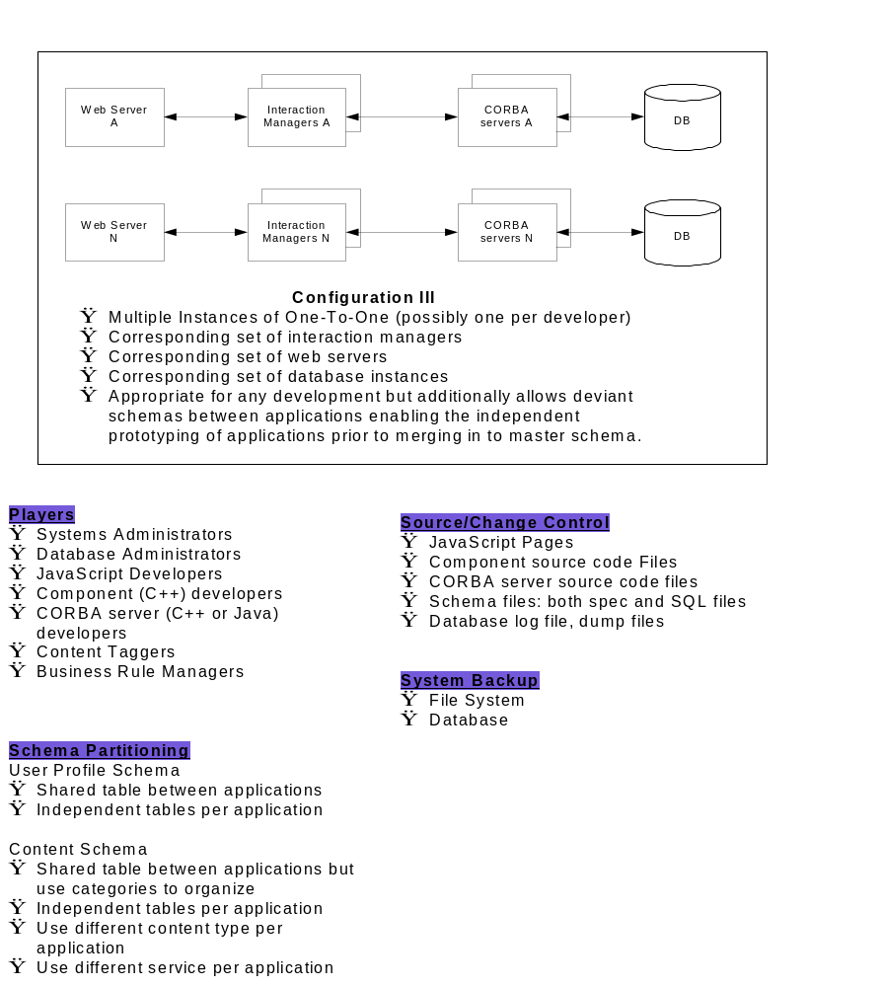

2.3 The Central Development/Testing Area

2.3.1 Revision Control
The Revision Control System must be able to support the storage, versioning and changes of all project artifacts.

Steps involved in delivering functionality fit for system test are:

- Artifact is checked into personnel area from development area.
- Implement changes and unit test code until satisfied.
- Check the artifact back into Central Development Area and perform an integration build and test. This may involve a merge due to code clashes; see below for means of mitigating against this.
- Freeze the code and dispatch the build to the system test area.

2.3.2 List of Artifacts

Artifact | Path | Description
bv1to1.conf | $BV1TO1_VAR/etc | Master configuration file
.bvlog.conf | $BV1TO1_VAR/etc | Logging level configuration file
bvobs.conf | $BV1TO1_VAR/etc | Observation configuration file
*.cfg | /etc/opt/BVSNsmgr | Interaction Manager configuration files
*.dat, *.dmp | $BV1TO1_VAR/data | Data dumps (Exports)
*.src | $BV1TO1_VAR/data | Schema definition files
*.conf | $BV1TO1_VAR/data | Loading script definition files
*.jsp | Script directory | Scripts
*.js | Start-up script directory | Start-up scripts
*.jsi | $BV1TO1_VAR | Script/Component Interface files
*.cc, *.hh | $BV1TO1_VAR | Component source files
*.html | Web server doc root | HTML files

DRAFT, DRAFT, DRAFT from here on ….

3.0 The Development Process

As parallel development will be in progress on a number of Use Cases there is the possibility of classes being shared ie branched at the file level. To reduce the likelihood of this the HTML Templates would be developed by one person, with a Use Case developer using a prototype template for white box testing. Try to ensure BV derived classes are specific to individual Use Cases.

Possibly take an overview of all Use Cases and their physical classes prior to commencement and use this to reduce the risk of having to branch classes.

Build and Test
The software will be built on a regular basis, frequency to be determined by the development team. Then run through a series of tests to verify the basic operation. The system should be in a known good state each day, a broken build must be fixed immediately.

This process should ideally be automated with a build tool such as Make.
The tests should evolve as the system evolves, initially the program may only perform a simple “Hello I am here”, as more functionality is added so the tests exercise more functionality.

It is suggested that a ‘Miniature Milestone’ approach to the first increment be adopted. The team organize the milestones typically at the Use Case basis but prior to these functional milestones the system framework is developed as smaller milestones, functionality can then be added on a Use Case basis. The pattern of work ensures a solid foundation and eliminates code integration problems which can often dog a project.

Techniques to validate the framework are stubbed interface, trace statements etc.

Miniature Milestones work well with a regular build and test. Code does not have to be checked in by the developer every day but only on completion of a task, as tasks are typically of a few days duration we end up with a stable evolving system.

Quality Assurance
Quality should be addressed throughout the lifecycle and as the project moves into implementation both execution testing and code reviews should be performed.

Code Walkthroughs
A walkthrough will be initiated by the developer who will provide a code listing with supporting model and documentation for the particular milestone. The review will take place between the buddy pair.
Criteria on which the code will be reviewed are:-
- Standards re [appendix A]
- Functional requirements expressed in the design model, with associated traceability for the logical model to physical implementation.
- Non functional requirements, consider what is likely to change eg business rules, file formats etc.
- Use Case scenarios.

Unit/White Box Testing
The developer checks his own code to verify it works as intended. Unit testing of classes is not necessary unless significant complexity and criticality warrants this.Tools/Techniques to aid the developer

- Integrated debugging environment
- Test harnesses
- Stubbed interfaces to other components
- Debug operations, traces etc
- Output to log files.

Link Testing
The developer will integrate the white box tested unit of work with the actual templates. Steps to validate the process

- Execute the template to class code using debugger
- Trace outputs from BV objects eg what operations are called when, assess logged output.

Prototyping
To ensure the technical feasibility of some areas of work such as inter package component communication it will be prudent to construct prototypes as proof of concept, the resultant code can be harvested into the actual system.

Change Control
If it is necessary to make changes in a deliverable after it has been released for general use, off-the-cuff changes cannot be made because of the knock-on effect they might have on other Project Team Members’ work. A controlled approach is the only way to ensure that all necessary changes are effected and everyone receives those changes in a controlled manner.

To achieve this we need to adopt a simple, common approach to problem reporting, change request & control:

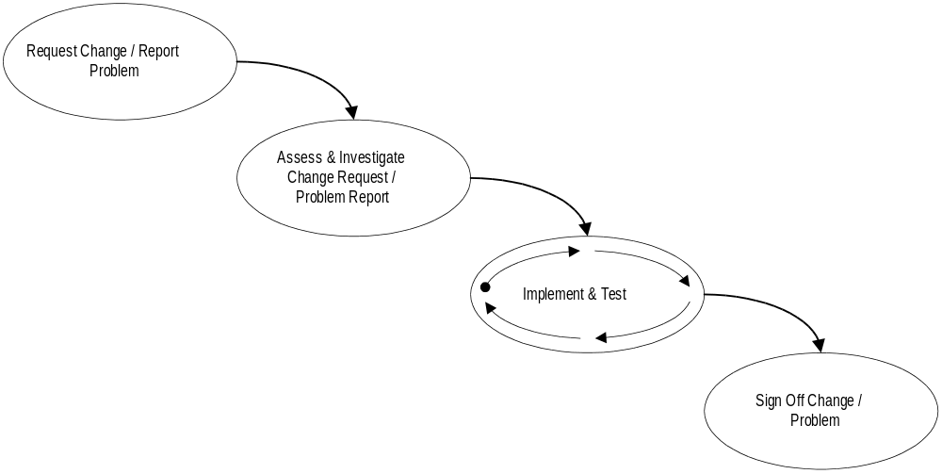

.

Appendix A - C++ Coding Standards
The standards are deliberately simple to ensure they are easy to learn and adhere to.

Naming
- All variable declarations should use the Hungarian notation. See Hungarian Notation section.
- All member attributes at a class scope shall be prefixed by ‘m_’.
- Any global variables shall be prefixed by ‘g_’
- All classes should be prefixed with ‘BOB_’. e.g. BOB_List.
- All variables should begin with lowercase e.g. int nMyIndex, CList myList. The latter is an instantiation of a class and therefore doesn’t require the Hungarian prefix.
- Methods names should start with uppercase.
- Use uppercase to indicate the first letter of a new word.

General Layout
- Use the standard indent of four spaces.
- Use indentation to convey program structure. This includes enter statement blocks, test/outcome, iteration.
- Space information within brackets to improve clarity. E.g.
int Add( BOOL bFlag )
{
int nData = 0;

if( bFlag )
DoTrueOutcome();
else
DoFalseOutcome( nData );

return nData;
}

- Try to layout algorithms so that debugging can follow the outcome of tests easily. i.e. always put the test and the outcome on different lines. See above example.

File layout and Commenting( refer to the example)
Header Files
- Optional corporate comment block followed by module description.
- Use a conditional macro to prevent multiple includes. E.g.
#ifndef _MYFILE_H
#define _MYFILE_H
.................
#endif // _MYFILE_H
The name should represent the file name in uppercase, use the format as in the example.
- All class definitions should be prefixed by a comment block.
- The following comment categories should be used in the order indicated, if there are no entries for the category then the comment can be omitted:
// Constructors | constructors as well as initialization function e.g. Create.
// Attributes | contains generally public attributes, typically member variables or ‘Get’ and ‘Set’ functions. The latter may or may not be virtual.
// Operations | contains generally member functions that a client can call on the object.
// Overridables | contains virtual functions that you can override in a derived class introduced at this level.
// Implementation | contains all the implementation details( usually private ). Both member variables and member functions can appear in this section. Everything below this line could change in future releases. Overrides of virtual functions in the base classes reside in this section( typically protected ) if the virtual function is to be potentially overridden again use the key word virtual( not required by the compiler but a useful documentation. The class destructor will also reside here.
- Supplementary comments to attributes should be made to the right of the attribute.
- Supplementary comments to methods should precede the method.

Implementation Files
- Optional corporate comment block followed by a module description if deemed necessary.
- Class implementations should be prefixed by a comment block.
- Group methods according to the categories established in the header file. In no entries exist then the category comment can be omitted.
- Always comment your algorithms and code. Only comment what is not understood. Over commenting can also obscure details and reduces understanding.

Hungarian Notation

Variable Prefix Naming Conventions
Prefix | Data Type
ch | char
n | short or long or int or UINT
b | BOOL (int)
w | WORD (unsigned word)
dw | DWORD (unsigned long)
fn | function
sz | string terminated by 0 byte
p | pointer
f | float
d | double
h | handle

General Prefix Naming Conventions
Prefix | Type
C | Class or structure
m_ | Member variable

Exceptions To The Normal Naming Conventions
Prefix | Data Type
x, y | short (used as x-coordinate or y-coordinate)
cx, cy | short (used as x or y length; the c stands for ”count")

Artifacts include source code, configuration files, scripts, documentation, etc.

